**DAILY ONLINE ACTIVITIES SUMMARY**

|  |  |  |  |  |  |  |
| --- | --- | --- | --- | --- | --- | --- |
| **Date:** | **24/06/2020** | | | **Name:** | **Chandana Patil** | |
| **Sem & Sec** | **6th Sem & A Sec** | | | **USN:** | **4AL17CS020** | |
| **Pre-Placement Training Summary** | | | | | | |
| **Pre placement training** | **9:00 am to 11:00 am - Programming in Java**  **11:00 am to 1:00pm - Data structures in C** | | | | | |
| **Faculty** | | **1.Ms. Shilpa**  **2. Mr. Venkatesh Bhat** | **Duration** | | | **4 hrs** |
| **Assessments** | | | | | | |
| **Problem Statement:**  **1.** Create a class named 'Shape' with a method to print "This is This is shape".  Then create two other classes named 'Rectangle', 'Circle' inheriting the Shape class, both having a method to print "This is rectangular shape" and "This is circular shape" respectively. Create a subclass 'Square' of 'Rectangle' having a method to print "Square is a rectangle". Now call the method of 'Shape' and 'Rectangle' class by the object of 'Square' class. | | | | | | |
| **Status: Completed** | | | | | | |
| **Uploaded the report in GitHub** | | | **Yes** | | | |
| **If yes Repository name** | | | [**https://github.com/chandanapatil/PrePlacement-Training.git**](https://github.com/chandanapatil/PrePlacement-Training.git) | | | |
| **Uploaded the report in slack** | | | **Yes** | | | |

**Training snapshots:**

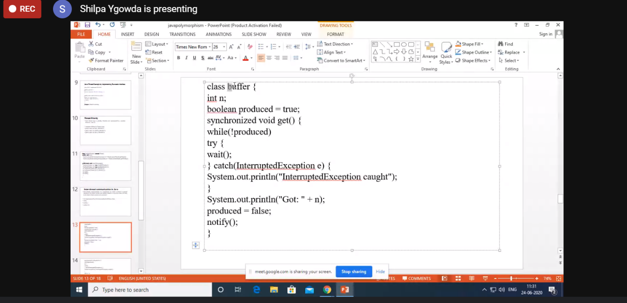

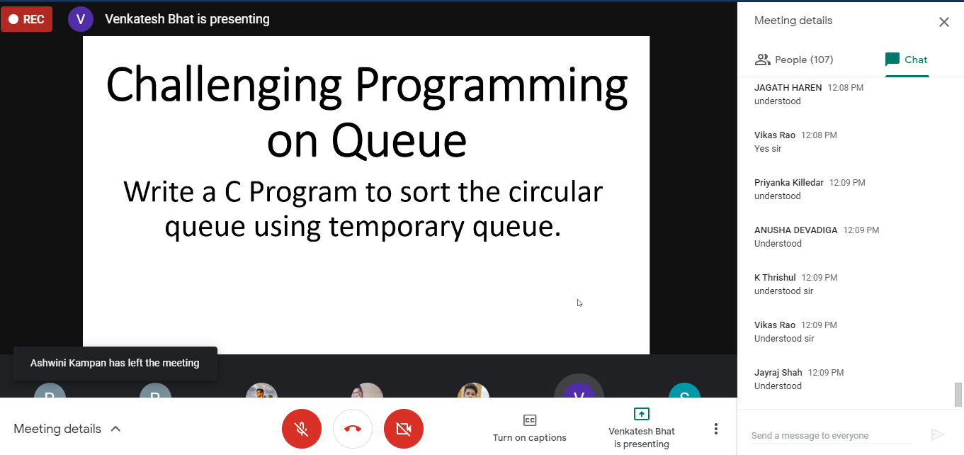

**Assessments:**

Create a class named 'Shape' with a method to print "This is This is shape". Then create two other classes named 'Rectangle', 'Circle' inheriting the Shape class, both having a method to print "This is rectangular shape" and "This is circular shape" respectively. Create a subclass 'Square' of 'Rectangle' having a method to print "Square is a rectangle". Now call the method of 'Shape' and 'Rectangle' class by the object of 'Square' class.

